Michael Trepanier

General Ledger Assessment

For the first part of the assessment I Navigate to: **System Administrator > Security > User > Define**.

In the **Define User** form:

* Enter your desired **User Name**.
* Enter a temporary **Password** and confirm it.
* Set the **Password Expiration Days** to 60.
* Assign these responsibilities:
  + Vision Operation General Ledger
  + Vision Operation Inventory
  + Vision Operation Procurement
* Save your changes.

In the same **Define User** form:

* Verify the **Password Expiration Days** field is set to 60.

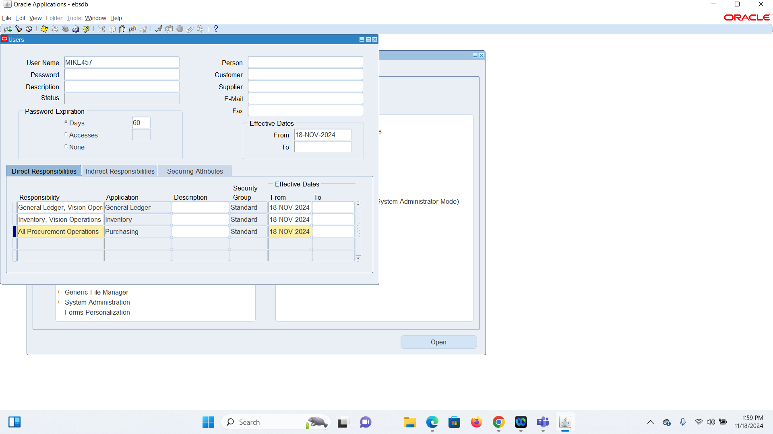

Ledger Details

* Switch to the **Vision Operation General Ledger Responsibility**.

* Navigate to: **Setup > Financials > Accounting Setup Manager**.

* Search for the **Vision Operation [Primary Ledger]** and open it.

For the Four Cs we have the Calendar: Accounting Calendar

Currency: Translation Options

Control: Budgetary Control

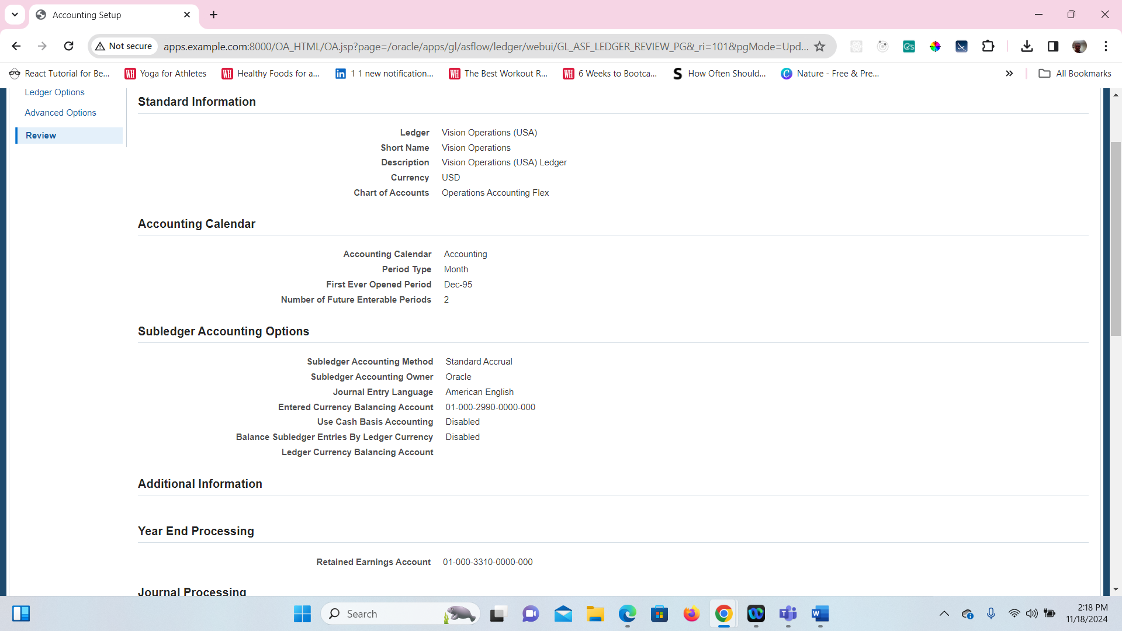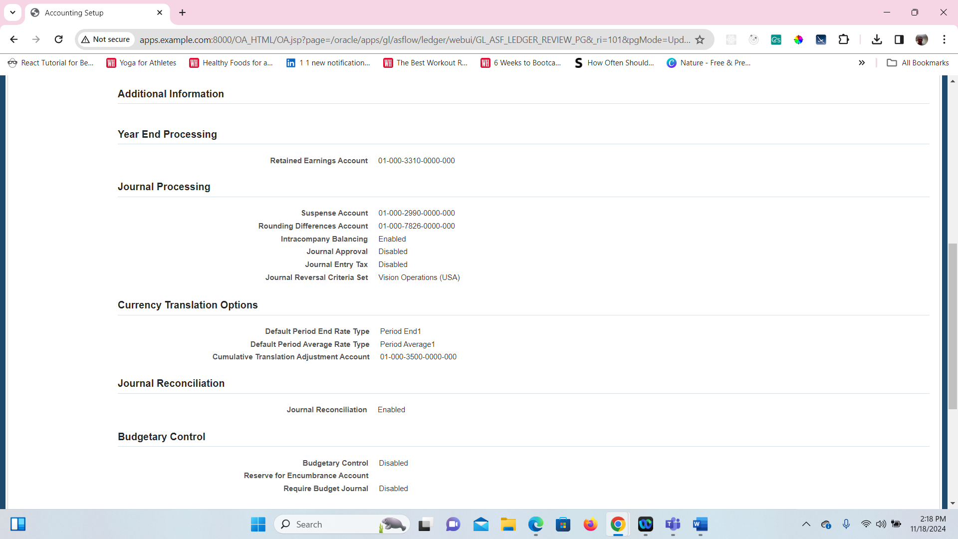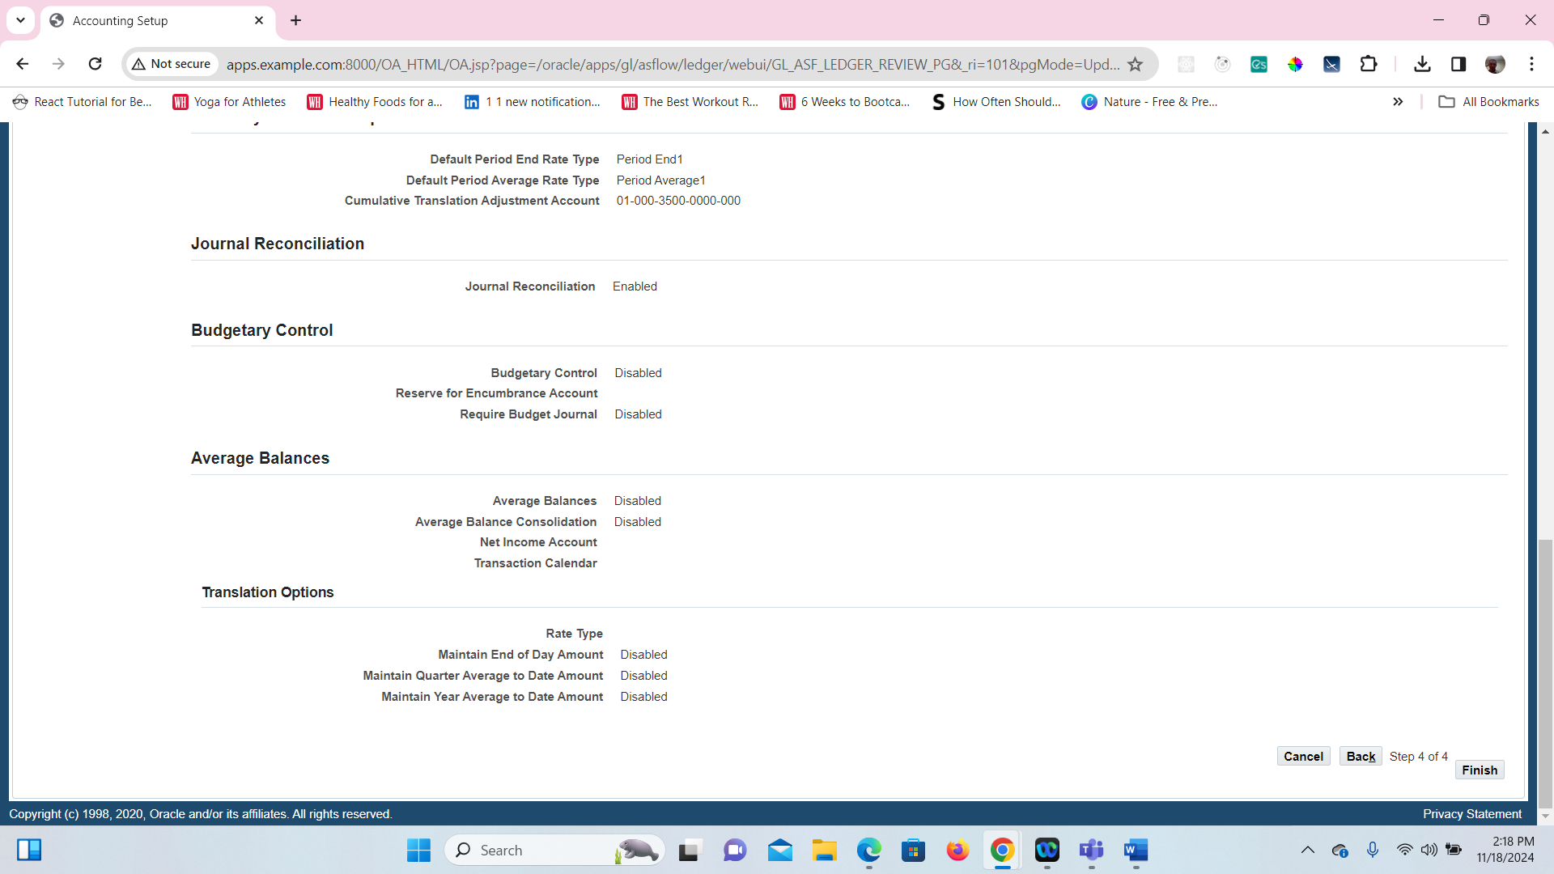

4. Find all the Account Code Combinations

General Ledger > Setup > Accounts > Combinations

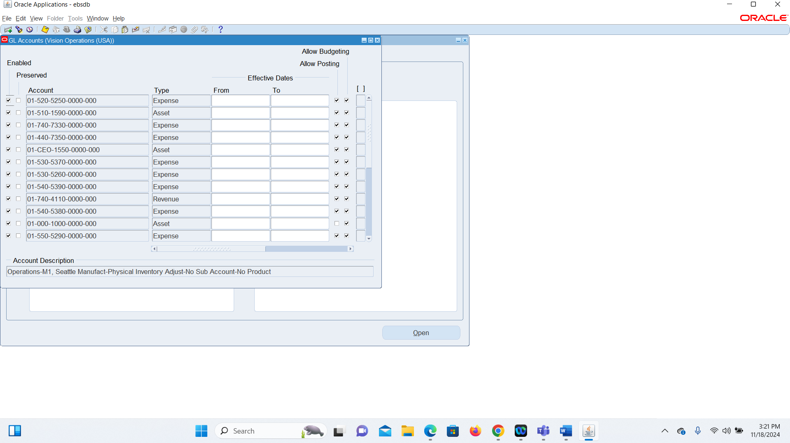

This is Number 5 Where I am finding all the Journals

* Ensure that you are logged in with the appropriate responsibilities and access rights (e.g., **Vision Operations General Ledger** or another relevant responsibility).

**Navigate to the "Enter Journals" Screen**:

* From the main **Navigator** screen, use the following path to go to the **Journals > Enter** screen:
  + **Journals** (menu)
* Once you are in the **Enter Journals** screen, locate the **Source** field in the journal entry form.
* In the **Source** field, select **Payables** from the dropdown list. This will filter the journal entries by the **Payables** source.

**Query for All Payables Journals**:

* After selecting **Payables** as the source, click **Find** (or press **Ctrl + F11** to perform the query).
* The system will return a list of all journal entries that have **Payables** as their source.

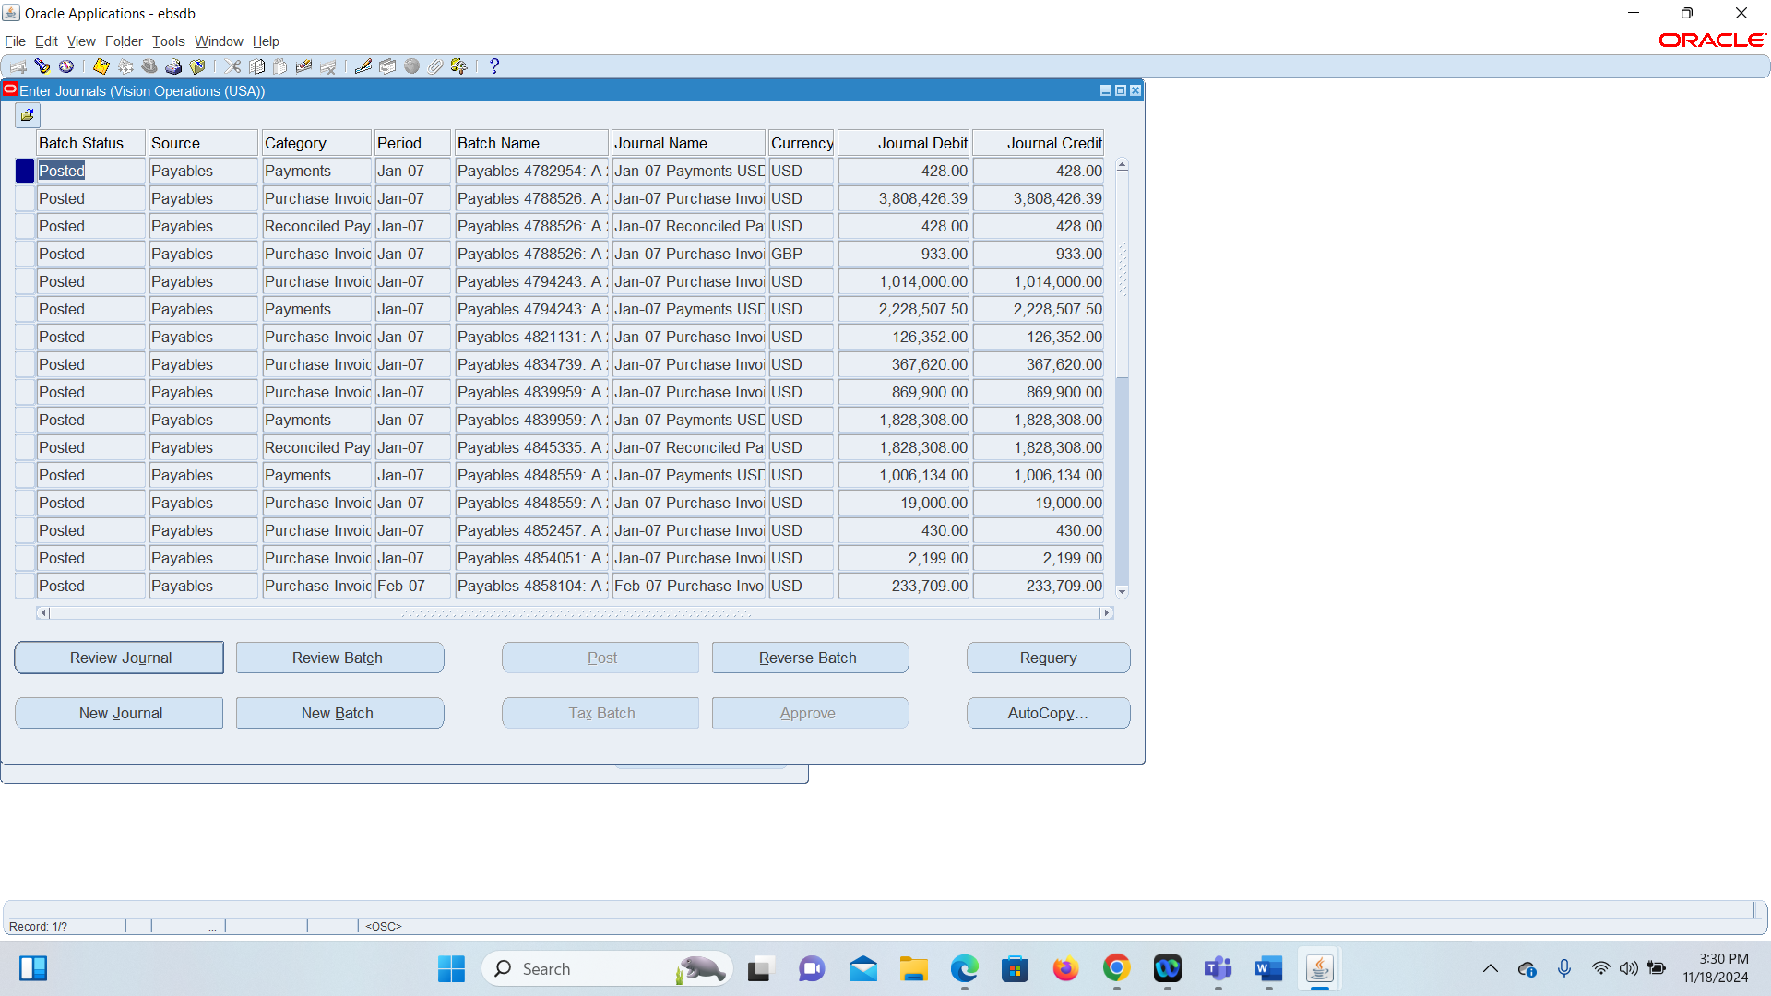

6.

**Identify Data Table Name**

1. While viewing a journal header, click on the **Help > Record History** option.
2. Identify the **Database Table Name** associated with the Journal Header.

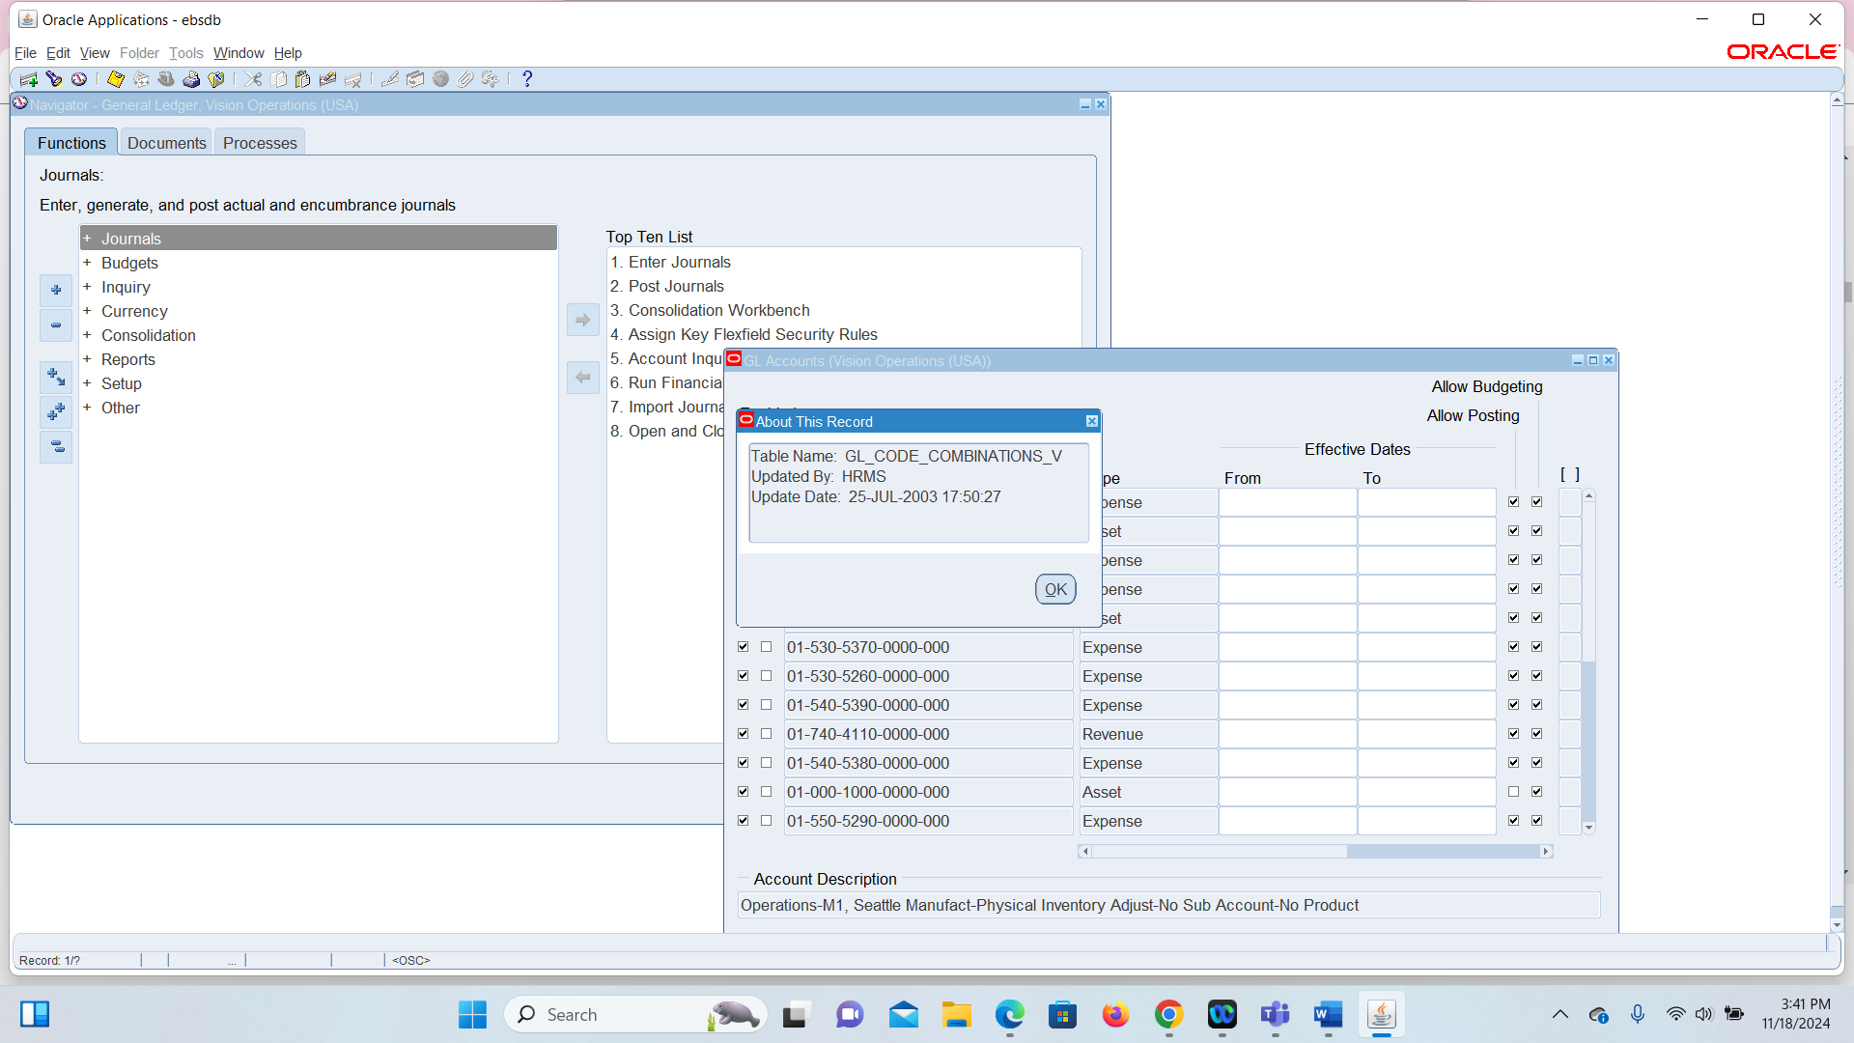

7. **Find One Manual and One Payable Journal**

1. Use the same **Journals > Enter** menu:
   * Query for a **Source: Manual** journal.
   * Query for a **Source: Payables** journal.

The same way I did 5 except this time I queried for Manual instead of Payables

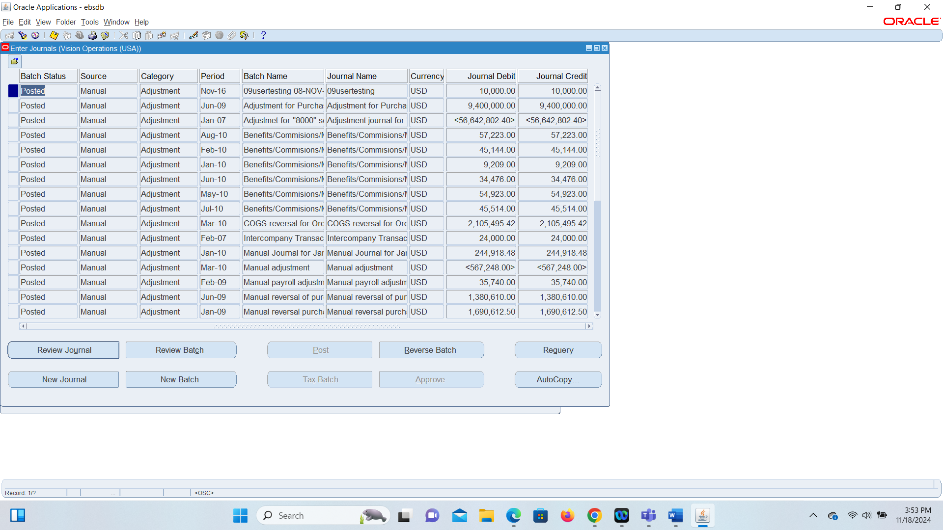

8. **Review Posted Journal Entries**

1. How you get to Journal and then Journal enter screen you just go to Query by example and then Query Enter it will pull up all the Posted Journals in the table.

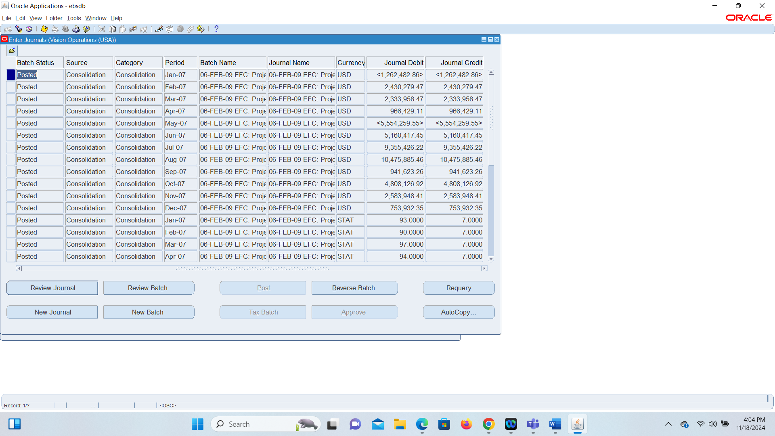

* Navigate to **Setup > Financials > Flexfields > Key > Segments**. This is where you can manage the **Chart of Accounts (COA) structure**.

**Access the Key Flexfields Setup**:

* In the **Key Flexfields Segments** screen, you will see an option to query and review the structure of the **Chart of Accounts**.
* Afterwards you can go to view and query by example and then query run and the data will show up

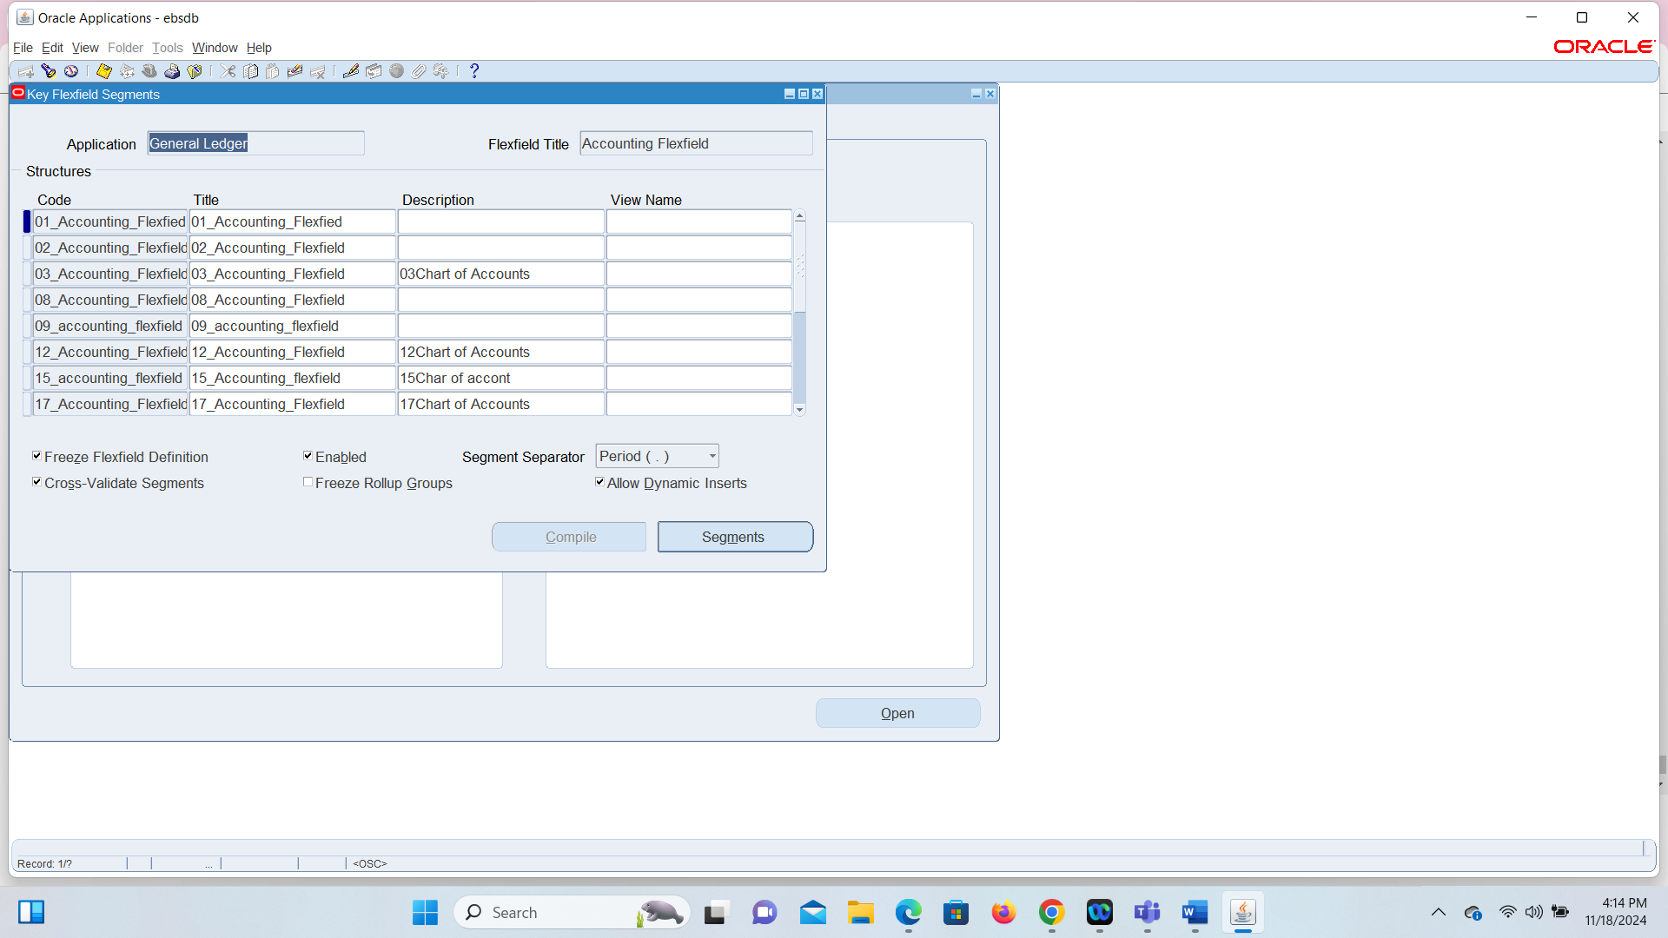

**Navigate**: Reports > Requests > Submit a New Request.

**Select**: **Single Request**.

**Choose Report**: Select **Trial Balance** (or any other report).

**Enter Parameters**: Set the required parameters (ledger, period, format).

**Submit**: Submit the request.

**Monitor Status**: Go to **View > Requests** to track the request.

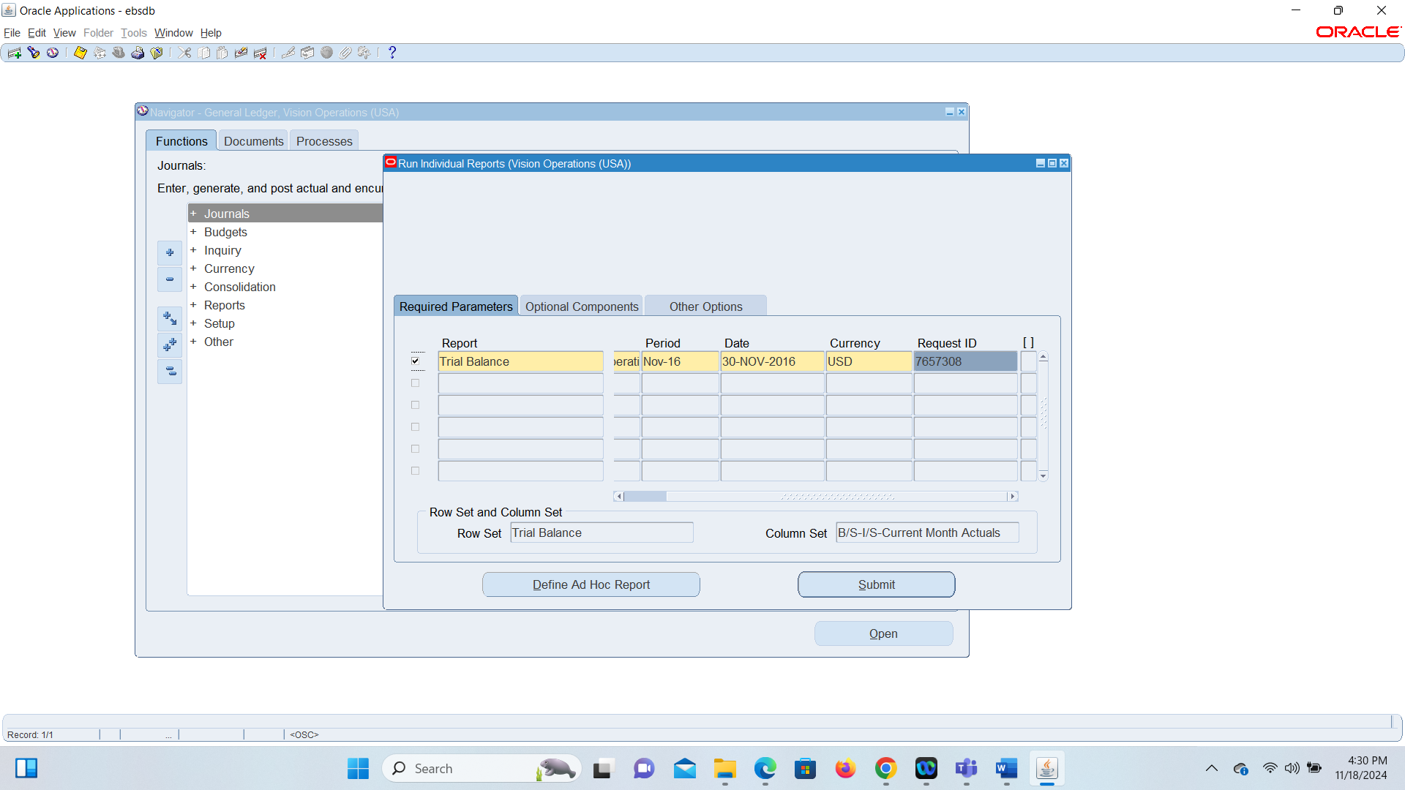

**Common Components in a Ledger Set**

1. Navigate to **Setup > Financials > Ledger Sets**.
2. Query a Ledger Set and identify common components (e.g., Chart of Accounts, Calendar, Currency).

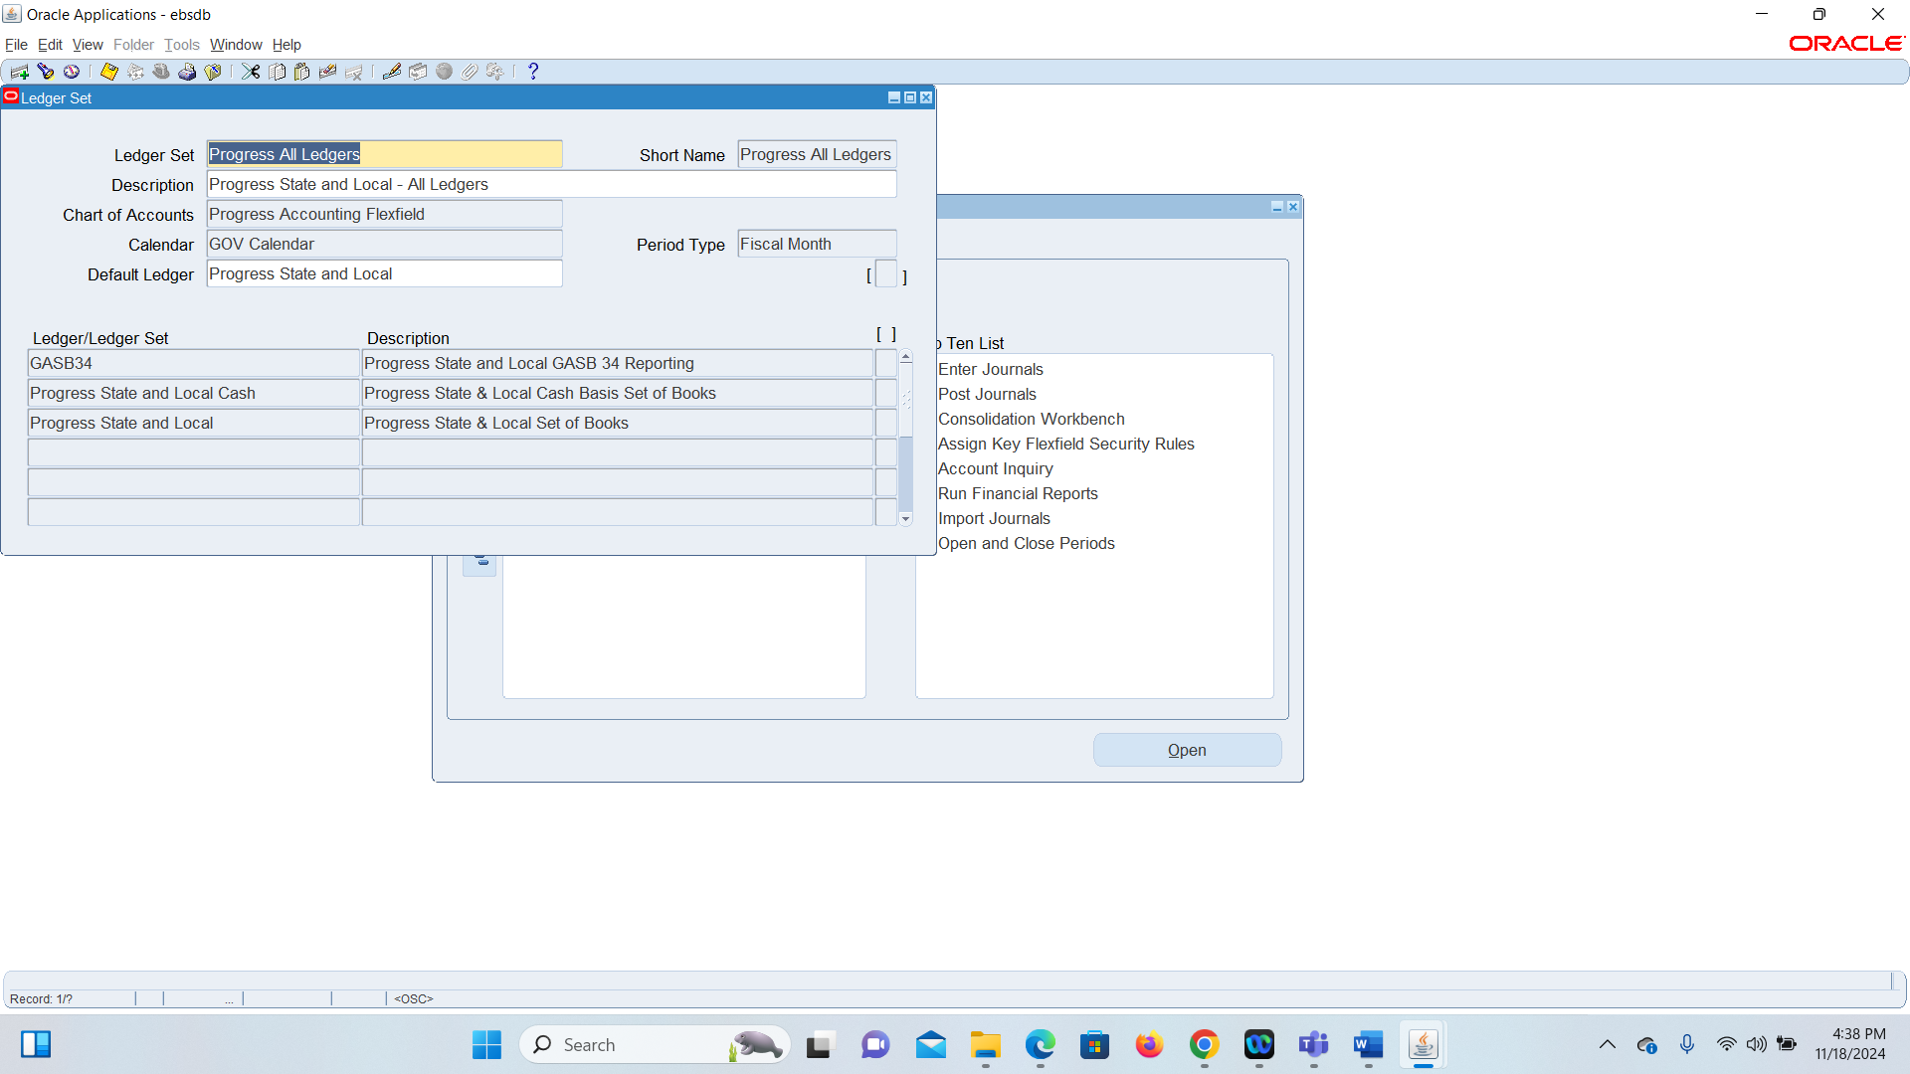

13.

Went to setup>accounts>combination

Then I just queried by example after that I queried and ran it

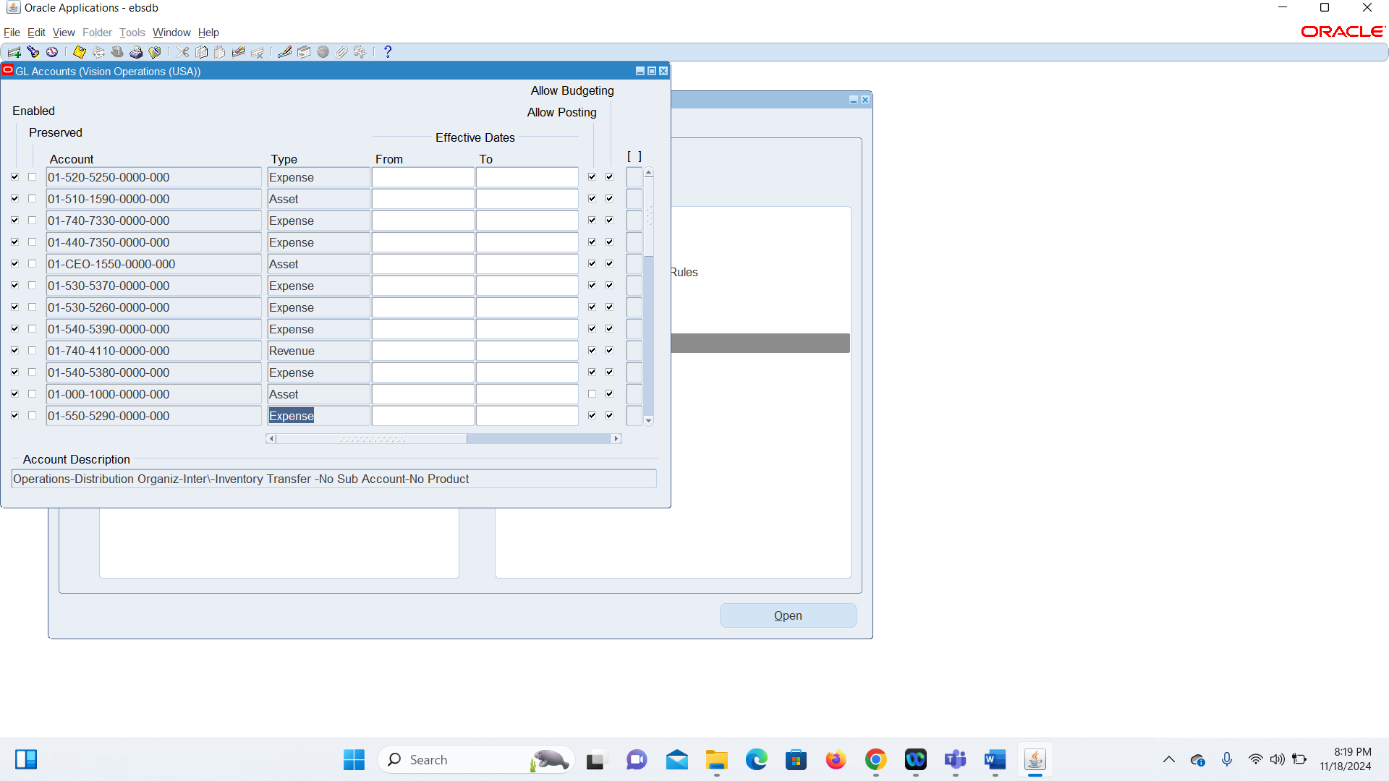

14.

Go to: **Setup > Financials > Flexfields > Key > Segments**.

Query the **Chart of Accounts**.

Review the **Segment Structure**, including details like Segment Names, Length, and Validation.

After I followed these steps I just ran the query by example

